Build 3.5 Play Testing: Variables

Game: Fling it Wing it

* Two player physics game.
* Targeted age 7-10 but opened to all age groups

Screenshots of current build

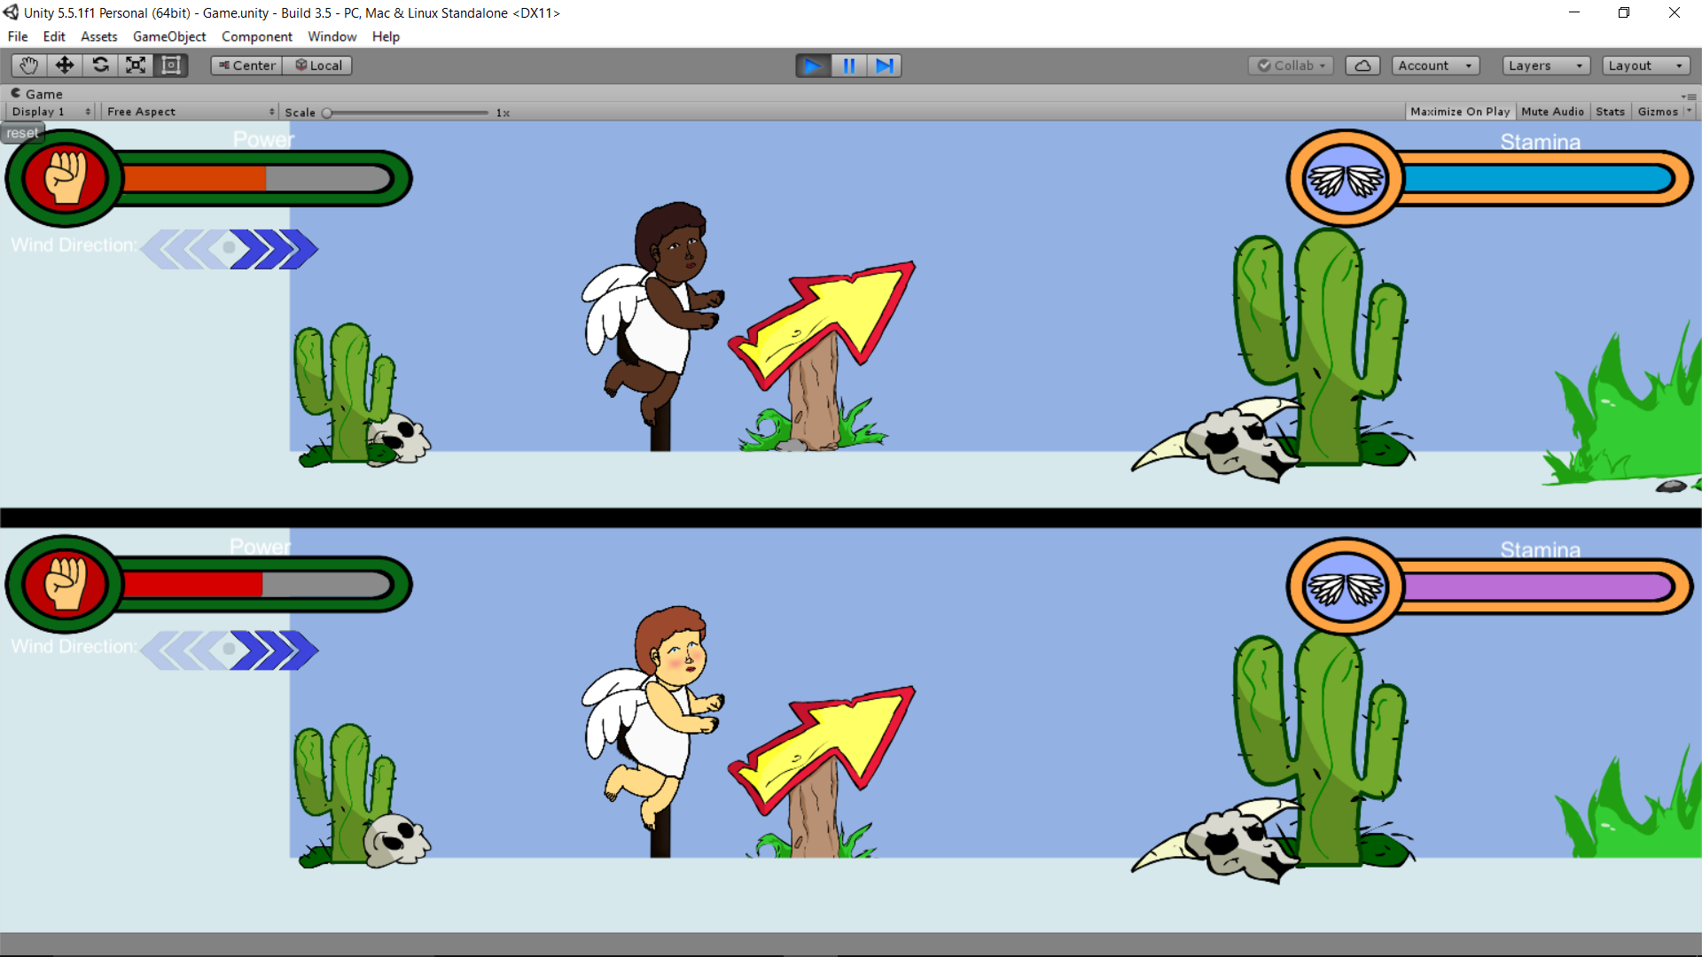

Player Details

* Player Gender: Male
* Player age: 12

Variables:

* How was the pacing of the game, too fast, too slow? Please elaborate:

Could have been slower. For more control

* How was the power applied to the bird, too powerful, too weak? Please elaborate:

Too weak didn’t travel far enough

* How was the bounciness of the ground, too bouncy, not bouncy enough? Please elaborate:

No bouncy enough. It would be more fun if it was bouncier.

* How was the power applied to the wind functionality, too strong? Not strong enough? Please elaborate:

No strong enough maybe too windy. The erratic nature of the wind was very entertaining it made me laugh.

Any other notes

I prefer the birds over angel things.

Very entertaining

Make controls easier.